Payroll Management System for Information Technology Company

Use-Case Specification: Update Working Time

Version 1.0

Revision History

|  |  |  |  |
| --- | --- | --- | --- |
| **Date** | **Version** | **Description** | **Author** |
| 15/12/2019 | 1.0 | Final | Quản Trong Tú |
|  |  |  |  |
|  |  |  |  |
|  |  |  |  |

Table of Contents

1. Use-Case Name 4

1.1 Brief Description 4

2. Flow of Events 4

2.1 Basic Flow 4

3. Special Requirements 5

4. Preconditions 5

5. Postconditions 5

6. Extension Points 5

Use-Case Specification: <Update Working Time>

# Use-Case Name

## Brief Description

This use case defines the steps of updating a working time for user who are working in company to store it in the database system. Administrator can easily update a exist working time for each user and themselves.

## Actor

Administrator

# Flow of Events

## Basic Flow

The system Administrator type the user id and click search to find out the information of user and know their time was declared or wasn’t declared. If their working-time was created, the administrator will perform updating working-time function. The system will display the values in the table.

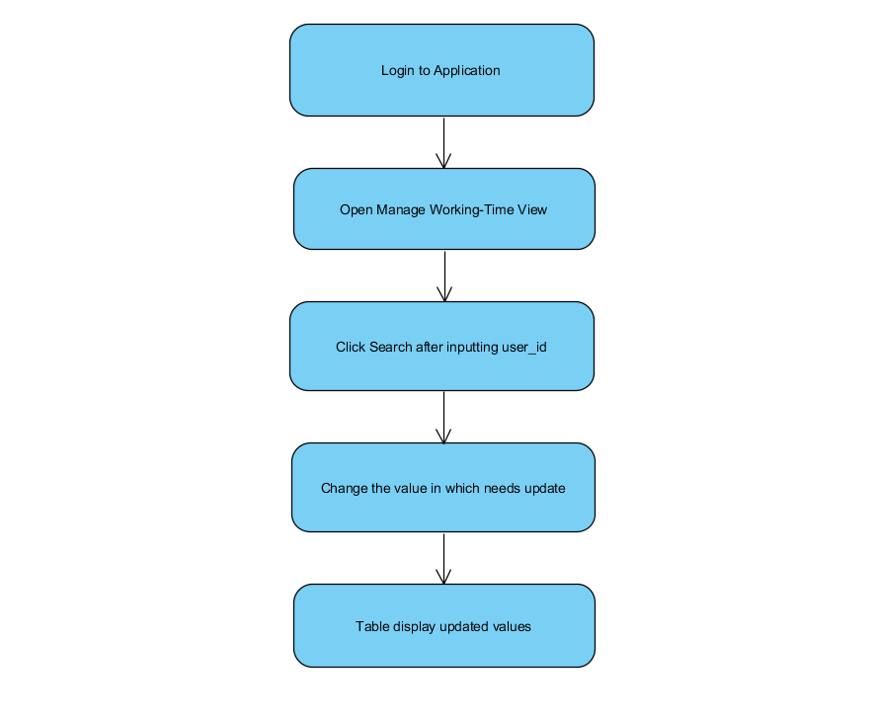

Basic Flow of Adding Working Time

# Special Requirements

* Administrator need to input correctly constraint.
* Search user success.

# Preconditions

* Administrator have to login into application and access Manage Working-Time view.
* If the user was created Working Time before, the administrator can update a Working-Time for this user.

# Postconditions

Show Message status of this function.

# Extension Points

No extension points.